PROGNOSTIC INVESTIGATION OF MALNUTRITION IN INFANTS USING ML

Mrs.Mouna K M

*Assistant Professor,Dept of ECE*

*BGS Institute of technology*,

Karnataka,India

mounakm@bgsit.ac.in

Mr. Rakshith Gowda K

*4th year,dept of ECE*

*BGS Institute of Technology,* Mandya ,India

rakshithgowda71002@gmail.com

Ms. Rakshitha B Bendre

*4th year,dept of ECE*

*BGS Institute of Technology*, Mandya,India

rbbendre57@gmail.com

Mr. Sharath Y M

*4th year,dept of ECE*

*BGS Institute of Technology,*

Mandya,India

sharathymsharthym@gmail.com

Mr. Y E Srujan Krishna

*4th year,dept of ECE*

*BGS Institute of Technology*,

Mandya,India

srujankrishnaye555@gmail.com

*Abstract* -This study proposes a data science machine learning approach to predict malnutrition status in children under five years old, a significant health issue affecting a country's economic growth. Utilizing training datasets from Kaggle, hidden factors are extracted using machine learning techniques, and classification algorithms such as Bayesian classifier and K-nearest neighbor are employed for prediction. The system is built as a real-time application using Visual Studio as the front-end technology and SQL Server as the back-end technology, demonstrating the accuracy of data science classification techniques in predicting malnutrition status based on clinical datasets.

*Keywords- Child Malnutrition, Malnutrition status prediction, Machine Learning, Data Science, Classification techniques, Bayesian classifier, Real-time application, Clinical data sets, Economic growth, Health issue , Developing countries.*

I. INTRODUCTION

Child malnutrition is a pressing concern in developing countries, with far-reaching consequences for both individual children and the broader economy. Adequate nutrition is essential for children's survival, growth, and development, and neglecting it can perpetuate cycles of poverty and underdevelopment. Fortunately, data science and machine learning have emerged as powerful tools in the fight against malnutrition.

By leveraging these technologies, healthcare professionals can predict the malnutrition status of children under five with greater accuracy. This enables early identification of at-risk children, allowing for timely interventions that can mitigate the adverse effects of malnutrition. Classification techniques, such as Bayesian classifier and K-nearest neighbor (KNN), are particularly effective in predicting malnutrition status. These algorithms can be applied to clinical datasets to uncover hidden factors contributing to malnutrition.

The development of real-time applications is critical for translating predictive models into practical solutions. By integrating these models into user-friendly interfaces, healthcare providers can access critical information quickly and efficiently. This enables continuous monitoring of children's nutritional status, allowing healthcare professionals to evaluate the effectiveness of interventions and make data-driven decisions.

The application of machine learning algorithms to child nutrition represents a significant breakthrough in public health. By harnessing the predictive power of these algorithms and the richness of clinical datasets, we can improve our ability to identify and address malnutrition in children. This investment in the health and prosperity of future generations has the potential to yield long-term benefits for individuals, communities, and nations as a whole.

II. RELATED WORKS

Several studies have explored the application of machine learning algorithms to classify and predict various health disorders in children. For instance, Bebortta et al. (2020) employed the Random Forest (RF) algorithm to classify pathological disorders in children, achieving promising results. However, they noted that RF has limitations, including slow execution and unsuitability for real-time prediction. Similarly, Momand et al. (2020) applied RF to predict malnutrition status in children, but acknowledged its limitations in real-time execution and the need for more comprehensive solutions.

Other researchers have investigated the use of different classification techniques to analyze and predict various health conditions in children. For example, Mohammed et al. (2020) used Naïve Bayes and Logistic Regression to analyze anemia with risk factor specification, but their study was limited to two types of anemia and relied on a small dataset. Moreover, their approach may be inefficient when using the Multi-Layer Perceptron (MLP) technique. These limitations highlight the need for more robust and efficient algorithms to tackle complex health problems in children.

In addition to classification techniques, researchers have explored the application of computer vision and deep learning algorithms to assess nutrient content and predict health outcomes. Pfisterer et al. (2019) developed a deep autoencoder network to assess the nutrient content of pureed food, achieving an accuracy of 80%. However, their system requires images as input and relies on a deep learning algorithm, which may be computationally expensive. Furthermore, their approach may not be generalizable to other types of food or health conditions.

Spatial analysis has also been applied to nutritional epidemiology to identify patterns and trends in health data. Di Fino et al. (2019) used the 2-Varogram algorithm to analyze the distribution of various health data, but their approach was limited to providing descriptive statistics and did not offer further insights or solutions. These studies demonstrate the potential of machine learning and spatial analysis in addressing health problems in children, but also highlight the need for more comprehensive and integrated approaches.

these studies demonstrate the growing interest in applying machine learning and data analytics to address health problems in children. While they have made significant contributions to the field, they also highlight the need for more robust, efficient, and comprehensive approaches to tackle complex health problems. By building on these studies and addressing their limitations, we can develop more effective solutions to improve the health and well-being of children worldwide.

# III. PROPOSED METHODOLOGY

The proposed system predicts malnutrition in children under five years old by analyzing parameters like age, gender, height, weight, WAZ, HAZ, WHZ, and others, classifying them into stunted, underweight, wasted, and nutritional oedema statuses using Bayesian, KNN, and Random Forest classifiers. This doctor-facing application can be developed using Visual Studio and SQL Server, which provides a systematic way to manage data in a structured format, making it easier to analyze and work with specific data instances. The.NET Framework, including languages like C# and VB.NET, ASP.NET for web pages and services, and ADO.NET for database interaction, enables programmers to build robust and efficient applications that can handle complex data analytics tasks, ultimately providing healthcare professionals with a powerful tool to predict and address malnutrition in children.

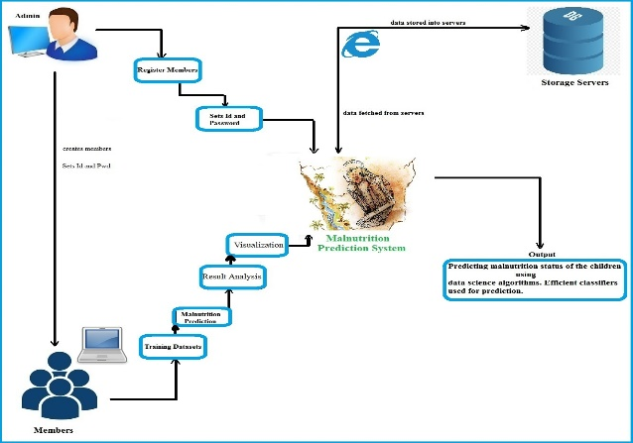

Fig.2: Data flow diagram

The system has two types of users, Administrators and Doctors, who log in with their credentials to access the application. Administrators manage doctors, view new and existing members, update passwords, and log out. Doctors register to access the application, manage training datasets, view malnutrition prediction outputs and algorithm results, update their profiles, and log out. Non-functional requirements include usability, reliability, maintainability, efficiency, and reusability, ensuring the system is user-friendly, reliable, easy to maintain, efficient, and accessible multiple times. The system requires a Pentium IV processor or higher, 2.4GHz processor speed, 2GB+ RAM, 40GB+ hard disk space, and a standard PC configuration. Software requirements include Windows 8 or higher, Visual Studio as the design tool, ASP.NET as the front-end, C# as the language, SQL Server as the database, and ADO.NET as the data access technology.

The design phase of the project involves planning a solution to meet the requirements, resulting in three outputs: architecture design, high-level design, and detailed design. The architecture design focuses on identifying components and their interactions, with a three-tier architecture chosen for this project, consisting of a data layer, business layer, and presentation layer. The high-level design identifies modules and their specifications, with a system architecture diagram and data flow diagram (DFD) used to visualize the system's components and data flows. The detailed design specifies the internal logic of each module, with use case diagrams, sequence diagrams, schema diagrams, state chart diagrams, and flowcharts used to model the system's behavior and interactions.

**Training Dataset**

|  |  |  |  |  |
| --- | --- | --- | --- | --- |
| **Patient Name** | **S1(X,Y,Z)** | **S2 (A,B,C)** | **S3 (P,Q,R)** | **Disease (subject)** |
| Eda | X | A | P | Yes |
| Siri | X | B | Q | Yes |
| Pooja | Y | B | P | No |
| Karan | Z | A | R | Yes |
| Ruhi | Z | C | R | No |

New Patient data – Adira

Parameters (S1 -X,S2-A,S3-R) Disease – Yes/ No

P=[n c + (m*p)]/(n+m)

|  |  |
| --- | --- |
| **Yes** | **No** |
| X  P= [n c + (m*p)]/(n+m)  n=2, n c=2, m=3, p=0.5  p= [2+(3*0.5)] / (2+3)  p=0.7 | X  P= [n c + (m*p)]/(n+m)  n=2, n c=0, m=3, =0.5  p= [0+(3*0.5)] / (2+3)  p=0.3 |
| A  P= [n c + (m*p)]/(n+m)  n=2, n c=2, m=3, p=0.5  p= [2+(3*0.5)] / (2+3)  p=0.7 | A  P= [n c + (m*p)]/(n+m)  n=2, n c=2, m=3, p=0.5  p= [2+(3*0.5)] / (2+3)  p=0.3 |
| R  P= [n c + (m*p)]/(n+m)  n=2, n c=1, m=3, p=0.5  p= [1+(3*0.5)] / (2+3)  p=0.5 | R  P= [n c + (m*p)]/(n+m)  n=2, n c=1, m=3, p=0.5  p= [1+(3*0.5)] / (2+3)  p=0.5 |

Yes– 0.7 * 0.7 * 0.5 * 0.5 (p) =0.1225

No – 0.3 * 0.3 * 0.5 * 0.5 (p) =0.0225

Since Yes > No

So this new patient (Akash - X,A,R) is classified to Yes.

The web application is built using an object-oriented programming language, which enables a modular approach to coding by organizing data and functions into separate memory areas. The project adopts a three-tier architecture, comprising ASP.NET for the user interface, C# classes for business logic, Table Adapter for data management, and MS SQL Server 2005 as the backend database. The Naive Bayes algorithm is employed to classify patient data, involving dataset scanning, probability calculation, and formula application to determine the likelihood of a particular outcome. This is illustrated through a sample example, where a new patient's data is categorized as "Yes" or "No" based on calculated probabilities, demonstrating the algorithm's effectiveness in predicting malnutrition status.

IV. RESULT

Testing is a critical step in software development that ensures a program's output matches the desired input. Errors can occur at any stage of development, and testing is essential for detecting and eliminating them. Early testing reduces the cost of fixing defects, while software defects can arise due to incorrect requirements, flawed design, poor coding, and other factors.

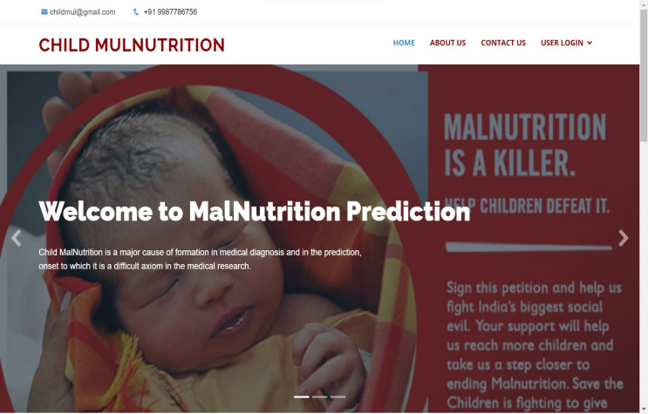

|  |
| --- |
|  |

Testing techniques include white box testing, which focuses on the program's control structure, and black box testing, which focuses on functional requirements. The purpose of testing is to ensure software quality, reduce development costs, and guarantee that the application behaves as expected. Various types of testing include unit testing, regression testing, stress testing, integration testing, user testing, and automation testing. Each type of testing has its unique focus, such as unit testing targeting the smallest unit of software design and stress testing pushing the application to its limits to reveal subtle bugs. By employing these various types of testing, developers can ensure that their software is of high quality, reliable, and meets the needs of their users.

Automation testing is a key aspect of software development, as it automates the manual testing process and provides benefits such as reliability, repeatability, and cost reduction. Automated testing can be applied to various types of testing, including functional, regression, exception, stress, performance, and load testing. Additionally, walkthroughs, reviews, and demos are essential in software development, as they help discover potential problems and improve the quality of work. By incorporating these testing methods, developers can build robust and high-quality software that meets customer expectations.

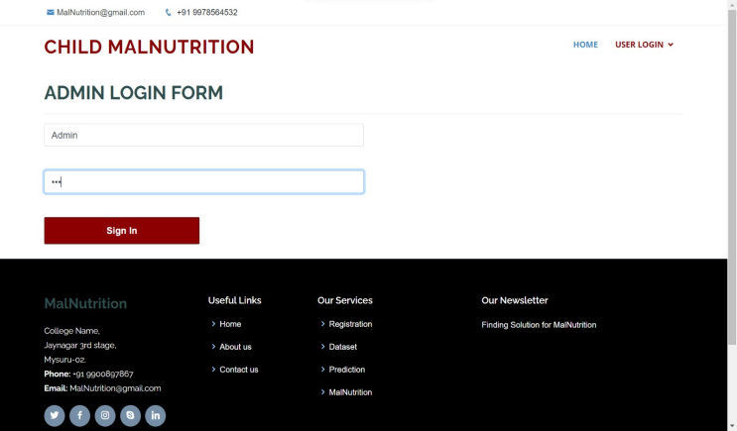

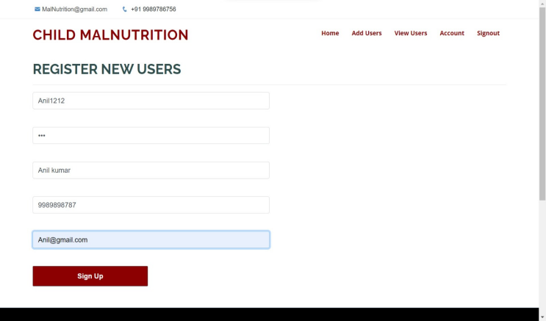

V. CONCLUSION

Nutrition plays a critical role in the overall health and development of children. Unfortunately, malnutrition remains a pressing global concern, affecting millions of young lives. To combat this issue, our proposed system aims to identify malnutrition in children under the age of five, categorizing them into four distinct groups: stunted, underweight, wasted, and nutritional oedema.

By leveraging a range of parameters, including age, gender, height, weight, and anthropometric indices, our system employs advanced classifiers to predict malnutrition with accuracy. Additionally, it detects anemia and provides personalized dietary recommendations to users. As a real-time application, this system has the potential to make a significant impact in the medical sector, ultimately improving the health and well-being of children worldwide.

##### References

[1] “Malnutrition in Children”. (n.d.). Retrieved June 13, 2019, from https://data.unicef.org/topic/nutrition/malnutrition/.

[2] “Joint child malnutrition estimates - Levels and trends (2019 edition)". (2019, June 06). Retrieved June 13, 2019, from https://www.who.int/nutgrowthdb/estimates2018/en/.

[3] Victora, C. G., Adair, L., Fall, C., Hallal, P. C., Martorell, R., Richter, L., & Sachdev, H. S. (2008). "Maternal and child undernutrition: consequences for adult health and human capital”. The Lancet, 371(9609), 340–357.

[4] Ministry of Public Health, Afghanistan. (2014). “Integrated Guidelines for the Management of Acute Malnutrition”.

[5] Black, R. E., Allen, L. H., Bhutta, Z. A., Caulfield, L. E., De Onis, M., Ezzati, M., & Maternal and Child Undernutrition Study Group. (2008). "Maternal and child undernutrition: global and regional exposures and health consequences”. The lancet, 371(9608), 243-260.

[6] Nandy, S., Irving, M., Gordon, D., Subramanian, S. V., & Smith, G. D. (2005). "Poverty, child undernutrition and morbidity: new evidence from India”. Bulletin of the World Health Organization, 83, 210-216.

[7] Maleta K. (2006). “Undernutrition”. Malawi medical journal: the journal of Medical Association of Malawi, 18(4), 189–205.

[8] “Malnutrition: Afghanistan’s silent emergency”. Retrieved June 13, 2019, from https://www.unicef.org/afghanistan/nutrition.

[9] Ministry of Public Health, Afghanistan. (2019). "Afghanistan Nutrition Cluster, 2018 annual report”.

[10] Ministry of Public Health (MOPH) - Afghanistan. (2004). 2004 "Afghanistan National Nutrition Survey”.

[11] Ministry of Public Health (MOPH) - Afghanistan. (2013). 2013 "Afghanistan National Nutrition Survey”.

[12] Ministry of Public Health (MoPH), ICF, Central Statistics Organization. (2017). “Afghanistan Demographic and Health Survey 2015”.

[13] Higgins-Steele, A., Mustaphi, P., Varkey, S., Ludin, H., Safi, N., & Bhutta, Z. A. (2016). "Stop stunting: situation and way forward to improve maternal, child and adolescent nutrition in Afghanistan”. Maternal & Child Nutrition, 12, 237–241.

[14] Akseer, N., Bhatti, Z., Mashal, T., Soofi, S., Moineddin, R., Black, R. E., & Bhutta, Z. A. (2018). "Geospatial inequalities and determinants of nutritional status among women and children in Afghanistan”: an observational study. The Lancet GlobalHealth, 6(4), e447–e459.

[15] Mashal, T., Takano, T., Nakamura, K., Kizuki, M., Hemat, S., Watanabe, M., & Seino, K. (2008). "Factors associated with the health and nutritional status of children under 5 years of age in Afghanistan: family behaviour related to women and past experience of war-related hardships”. BMC Public Health, 8(1).

[16] Ministry of Public Health, Afghanistan. (2018). “Integrated Management of Acute Malnutrition National Guidelines”. Kabul, Afghanistan: Public Nutrition Directorate.

[17] Khare, S., Kavyashree, S., Gupta, D., & Jyotishi, A. (2017). "Investigation of Nutritional Status of Children based on Machine Learning Techniques using Indian Demographic and Health Survey Data”. Procedia Computer Science, 115(2017), 338–349.

[18] Das, S., Hossain, M. Z., & Islam, M. A. (2008). "Predictors of child chronic malnutrition in Bangladesh”. Proceedings of the Pakistan Academy of Sciences 45(3): 137-155.

[19] Shahriar, M., Iqubal, M. S., Mitra, S., & Das, A. K. (2019, July). "A Deep Learning Approach to Predict Malnutrition Status of 0-59 Month's Older Children in Bangladesh”. In 2019 IEEE International Conference on Industry 4.0, Artificial Intelligence, and Communications Technology (IAICT) (pp. 145-149). IEEE.

[20] Senthilkumar, D., & Paulraj, S. (2015, March). "Prediction of low birth weight infants and its risk factors using data mining techniques”. In Proceedings of the 2015 International Conference on Industrial Engineering and Operations Management (pp. 186-194).

[21] Ariyadasa, S. N., Munasinghe, L. K., Senanayake, S. H., & Fernando, M. G. N. A. S. (2013, January). “Knowledge Extraction to Mitigate Child Malnutrition in Developing Countries (Sri Lankan Context)”. In 2013 4th International Conference on Intelligent Systems, Modelling and Simulation (pp. 321-326). IEEE.

[22] Reis, R., Peixoto, H., Machado, J., & Abelha, A. (2017). "Machine Learning in Nutritional Follow-up Research”. Open Computer Science, 7(1), 41–45.

[23] Markos, Z. (2014). "Predicting Under Nutrition Status of Under-Five Children Using Data Mining Techniques: The Case of 2011 Ethiopian Demographic and Health Survey”. Journal of Health & Medical Informatics, 5(2).

[24] Thangamani, D., & Sudha, P. (2014). “Identification of malnutrition with use of supervised datamining techniques–decision trees and artificial neural networks”. Int J Eng Comput Sci, 3(September 9), 8236-824.

[25] Hayat, C., & Abian, B. (2018, October). “The Modeling of Artificial Neural Network of Early Diagnosis for Malnutrition with Backpropagation Method”. In 2018 Third International Conference on Informatics and Computing (ICIC) (pp. 1-7). IEEE.

[26] Winiarti, S., Yuliansyah, H., & Purnama, A. A. (2018). "Identification of Toddlers’ Nutritional Status using Data Mining Approach”. International Journal of Advanced Computer Science and Applications (IJACSA), 9(1), 164-169.

[27] Cios, K. J., Pedrycz, W., Swiniarski, R. W., & Kurgan, L. A. (2007). “Data Mining: A Knowledge Discovery Approach”.

[28] “WHO Anthro Survey Analyser and other tools”. (2019, June 7). Retrieved September 3, 2019, from https://www.who.int/childgrowth/software/en/.

[29] Nitesh V. Chawla et. al. (2002). “Synthetic Minority Over-sampling Technique”. Journal of Artificial Intelligence Research. 16:321-3.

[30] World Health Organization. (2010). “Nutrition Landscape Information System. Geneva, Switzerland”: WHO.